**ELEVATOR SYSTEM**

**Table of Content**

**1. About the Elevator System**

1.1 Description

1.2 Identifying features

1.3 5W’s & 1H and S.W.O.T analysis

**2. Block Diagram and Blocks explanation**

2.1 Block Diagram

2.2 Flowchart

**3. Requirements**

3.1 High level requirements

3.2 Low level requirements

**4. Circuit Diagram**

**5. Test Plan and Output**

**6. Applications**

**7. References**

**1. About the Elevator**

**1.1 Description**

* An Elevator or Lift is a type of cable-assisted or roller-track assisted machine that vertically transports people between floors of building or other structure. They are typically powered by electronic motors that drive traction cables and counterweight systems such as a hoist, although some pump hydraulic fluid to raise a cylindrical piston like a jack.

**1.2 Identifying Features**

* Outside the elevators, buttons to go up or down.
* Automatic door opening and closing shall be provided
* Safety gates are attached to the elevator cab and will travel with the cab as it goes between floors.
* Interlocks keep passengers from opening the elevator door while moving, so you never have to worry about opening a door before fully stopping at a floor.
* The doors will remain locked until you reach a landing zone and will keep you safe, which is especially important with young, curious children or pets.
* An emergency alarm will alert everyone close by that you need assistance and an emergency stop switch, or button, will stop the elevator altogether.

**1.3 5W's 1H**

WHO - People who have Elevators in their Buildings

WHAT - It transports people between floors

WHEN - Whenever people want to travel across floors

WHERE - Anywhere inside the building

WHY - To save the time

HOW - By using down or up indicators of Lift.

**2. Block Diagram and Blocks explanation**

2.1 Block Diagram

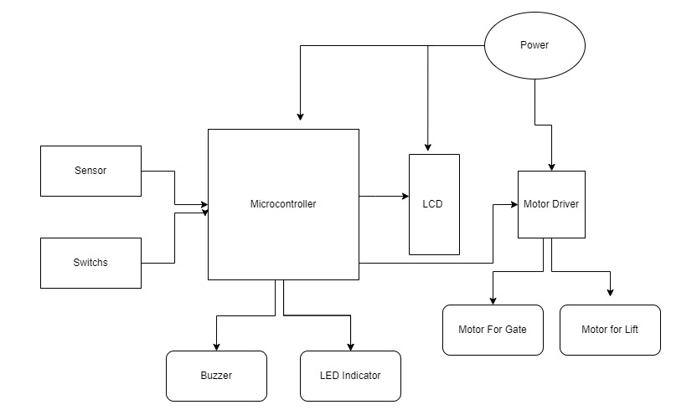

2.2 Flowchart

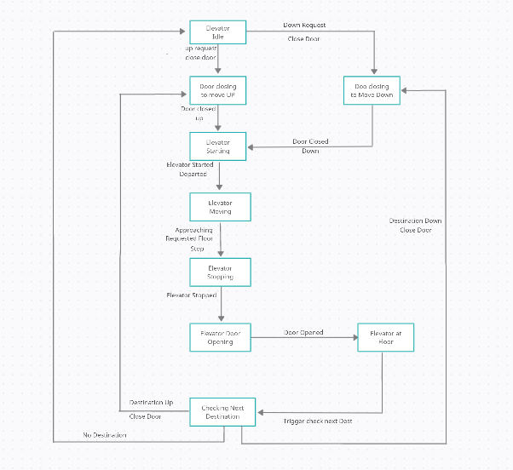

**3. Requirements**

**3.1 High Level Requirements**

HLR1 - Elevators should move up when called from upward and down when called from

downward. It moves exactly to that floor when corresponding floor no is pressed

HLR2 - Doors of elevator must open only when it reaches the floors

HLR3 - Inside the elevators it should display the current floor

HLR4 - Elevators should be capable of moving up and down

**3.2 Low Level Requirements**

LLR1 - It is stopping at each floor

LLR2 - Elevators should move up when called from upward and down when called from

downward.

LLR3 - No break points exists

LLR4 - The elevator should go to the nearest floor when two people are accessing lift from

different floors.

**4. Circuit Diagram**

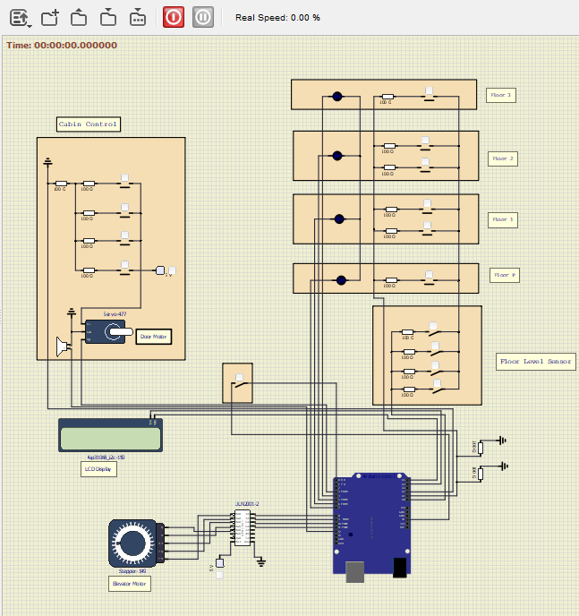

**5. Test Plan and Output**

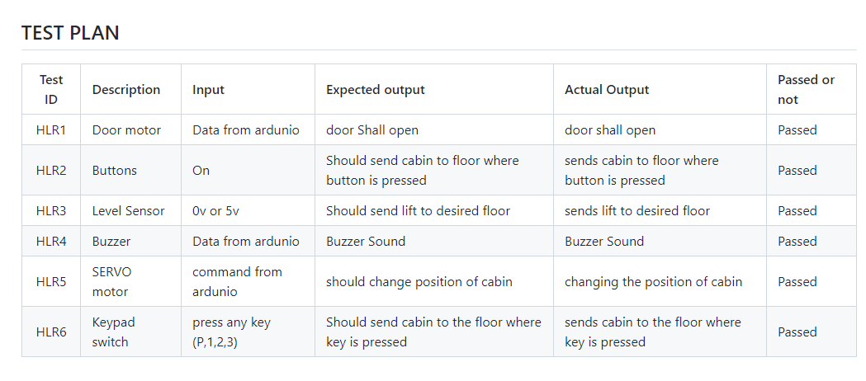

**6. Applications**

* These are used to transport people from one floor to another.
* They can also be used to transport heavy materials from floor to floor.
* An elevator offer ease as well as convenience, and also makes life easier for physically handicapped persons.
* An elevator can be installed in Apartments, Malls, Public Places etc
* In elevator can carry upto 1000kgs or more depending on the elevator developed

**7. References**

[**www.homeelevators/explore.com**](http://www.homeelevators/explore.com)

https://www.electronicwings.com